1. 
2. 
3. **Answer**:
   1. With Help of Step Definition and Regular Expression Context.
   2. **Example**:
      * 1. 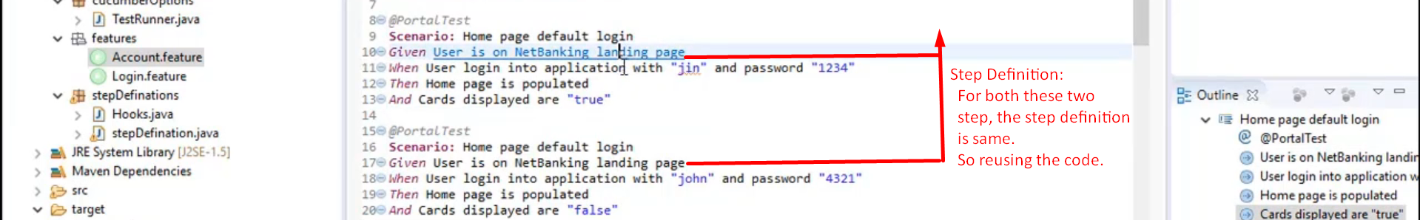
        2. 
4. **Question**:   
   
   1. **Answer**:
      1. In traditional Automation Testing Framework, you have to write a lot of code to get data as data is put in some external files.
      2. But in Cucumber, the data can be defined along with scenario/test case and using DataTable, we can get the data.
5. **Question**: 
   1. **Answer** : Using **Scenario Outline along with example.**
6. **Question**:  
   
   1. **Answer**: Each and every step in feature file achieved. If not, Cucumber will report that in console.
7. **Question**:
   1. **Answer:** 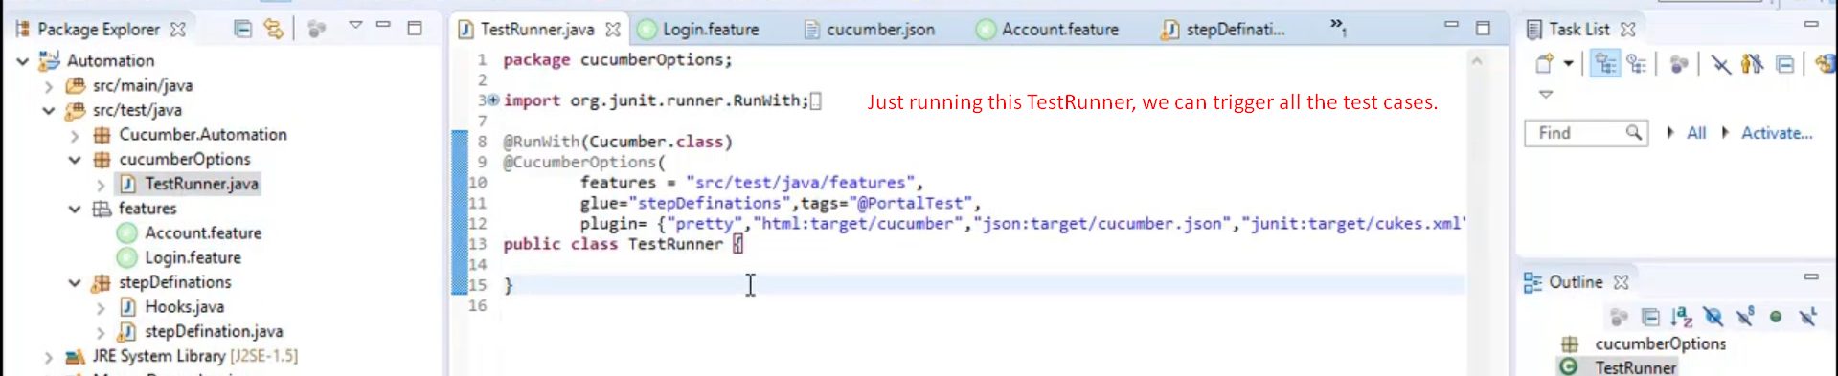
8. **Question**: 
   1. **Answer**: Putting Tag on Scenarios and using @CucumberOptions(tag=”@SomeTag”)
9. **Question**:
   1. **Answer**: With help of Hooks and Tags (@Before, @After), Background.
10. **Question:**
    1. **Answer:** @CucumberOptions(plugin = {“html:target/cucumber.html”, “json:target/cucumber.json”}
11. **The following Two questions are pending. We will work on them.**